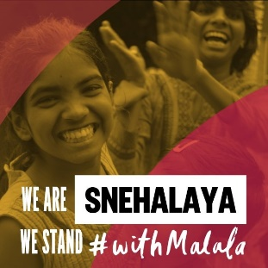

Educate. Empower. Lead.

Pledge of Support

I pledge to stand with Malala and Snehalaya in their mission to educate, empower and help girls to become leaders. I will create awareness about girl’s education in my family, my community, my country. I will abide by the fundamental duties alloted to me in the Indian Constitution.

By promoting equality in education, I hereby pledge to work to protect girls & prevent the sexual exploitation of children. So let us come together to create our future now and make today’s dreams tomorrow’s reality!

Name

Designation

Signature

Date

