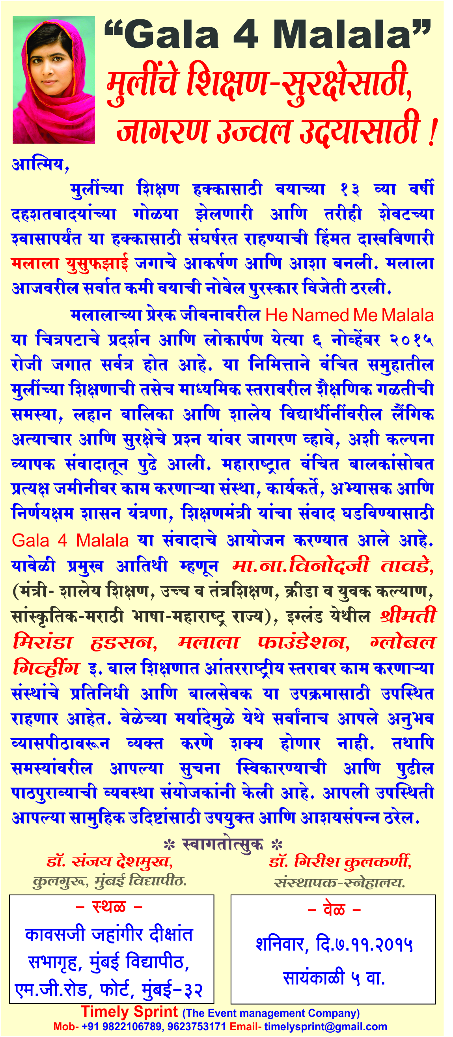
“GALA 4 MALALA”
“GALA 4 MALALA”
For security of girls-education, for alertness and progressive beginning of future!
Dear,
For the rights of women education, at the age of 13, the one who stood in front of terrorists, even they fired guns at her. She stood up front until her last breath. She has shown boldness and courage. She is Malala Yousafzai. She became worldwide center of attraction and a ray of hope for girls. Malala is the youngest person in the world who has won the Noble Prize.
Based on Malala’s inspirational life story, a movie named “He Named Me Malala” will be released in theatres and will be made available to public on November 6th, 2015 worldwide. On this occasion, girls who are deprived of education, other issues related to their termination from school-life at high school levels, sexual abuse of school girls, younger (nursery, primary level) girls as well as tortures, and control measures based on their security should be discussed publicly and public should be made aware. This idea came from widespread discussions conducted during some or other times. Organizations, workers, scholars, decisive governmental system and minister of education (who work at grass-root level with/ for deprived kids) were invited for meetings (combined discussion) in a program. This program is named as GALA 4 MALALA. On this program, chief guest will be resp. Vinodji Tawde (Minister- School Education, Minister Of Higher & Technical Education – Maharashtra State, Minister of Marathi Bhasha (Language) Cultural Affairs, Sports and Youth Welfare – Maharashtra State), Miss Miranda Hudson from England, Malala Foundation, Global Giving and other representatives who work at global level for child education as well as child servants will remain present for this program. Due to time limitations, it would be impossible for everyone to conduct speeches and express themselves on stage. Still, the organizing committee has promised to accept all notices, suggestions, information. They promised that collected information will be sent to higher bodies and will be noticed (taken into consideration for future plans or will be brought into action). Your presence would be helpful and content-rich for achieving various social objectives.
• We are waiting for your hearty welcome. •

Dr. Sanjay Deshmukh,
Honorable Vice Chancellor, Mumbai University.

Address:
Kawasaji Jahangir Dikshant Sabhagruh (Meeting Hall), Mumbai University, M.G. Road, Fort, Mumbai – 32.
Dr. Girish Kulkarni
Founder, Snehalaya.

Timing:
Saturday, November 7th, 2015.
Evening 5 PM.

Timely Sprint (The Event Management Company), Mobile Number: +91-982-210-6789, +91-912-675-3171, Email – timelysprint@gmail.com

